MOAA UNIFORMED SERVICES NURSE ADVOCATES VIRTUAL CHAPTER

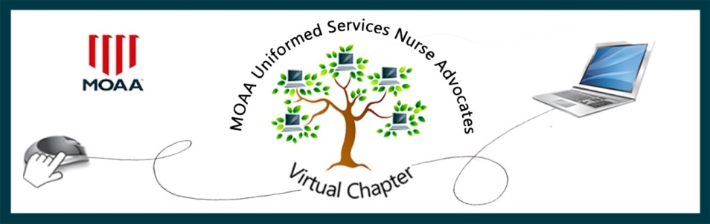

MEMBER SPOTLIGHT FEATURE

Organizations of all sizes and with all missions profit from “team building” activities. This is particularly true for military (or Uniformed Service) organizations. Who doesn’t remember those Friday afternoon “happy hours” and “off sites” aimed at fostering camaraderie and improving relationships within an office? Getting to know your fellow workers on a personal, as well as a professional, level is just good business.

Our MUSNAVC Virtual Chapter is centered around common/shared nursing experience. Under that overall umbrella, however, we have members with widely varied backgrounds, experience, and expertise. Some are Junior Officers, still on active duty, while many are retired Senior Officers who have left a full military nursing career to move on into other fields where they continue to “Never Stop Serving”. Some are happily retired and support our goals by responding to “Calls for Action” and focused advocacy efforts. Some are deeply engaged in community involvement and support to local MOAA Councils and Chapters.

Around the world, organizations have been forced into new business models, relying on virtual meetings and provision of services. In our case, to paraphrase an old country song…”We were Virtual, when Virtual wasn’t cool”. We think that we are doing a pretty good job with our core advocacy efforts, and we will continue to look for ways to get even better at that. What we are hoping to do through this new “Member Spotlight” feature is to help our members get to know each other a little better by sharing some of our personal information, background, and experiences. We hope that this might provide the framework for forging new friendships and enabling opportunities for mentoring and sharing.

We invite you to fill out the attached form and send it back to musnavc@gmail.com with the subject line of “Member Spotlight”. We envision a special page on our website where these can be posted and hope to get input from all services and encourage wide participation. Please understand that we may need to edit submissions. Don’t look at this as us asking you to “toot your own horn” because most of us would not really feel comfortable doing that. See it more as just an opportunity to share your background with somebody you’ve just met at a party and discovered that you share some things in common.
.

Take care and Cheers…Jeri and Joe

MOAA UNIFORMED SERVICES NURSE ADVOCATES VIRTUAL CHAPTER
MEMBER SPOTLIGHT

Yes! I would like to be part of this exciting new feature. DATE: Click here to enter text.

NAME, (LAST, FIRST, MI): Click here to enter text. RANK: Click here to enter text.

SERVICE: Click here to enter text. DATES OF SERVICE: Click here to enter text.

RESIDENCE ADDRESS (CITY, STATE): Click here to enter text.

LAST TWO DUTY STATIONS AND POSITION HELD: Click here to enter text.

TELL US OF A MEMORABLE EXPERIENCE AS A MILITARY NURSE: Click here to enter text.

TELL US OF A SIGNIFICANT CONTRIBUTION YOU MADE TO MILITARY NURSING: Click here to enter text.

TELL US OF ANY COMMUNITY INVOLVEMENT OR CURRENT ACTIVITY: Click or tap here to enter text.

TELL US WHY MILITARY NURSING IS DIFFERENT AND/OR SPECIAL: Click here to enter text.

Fill in this form on your computer, save it, and then email it to us as an attachment.
Please email to: musnavc@gmail.com.

Please include a photo you would like us to use in the Spotlight.

Thank you for participating and sharing your wonderful experiences and knowledge. Please call or email with any questions.

Joe Gollasch Jeri Graham
727.233.6522 910.616.3487

